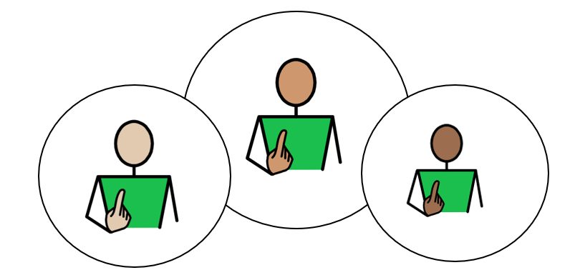
All about Me

Appendix 1A: Pathway 3 (Secondary)
Voice of the Young Person

We use our Children’s and Young People’s Outcome Framework, below, to make sure that the support provided for you is having a positive impact on your life.
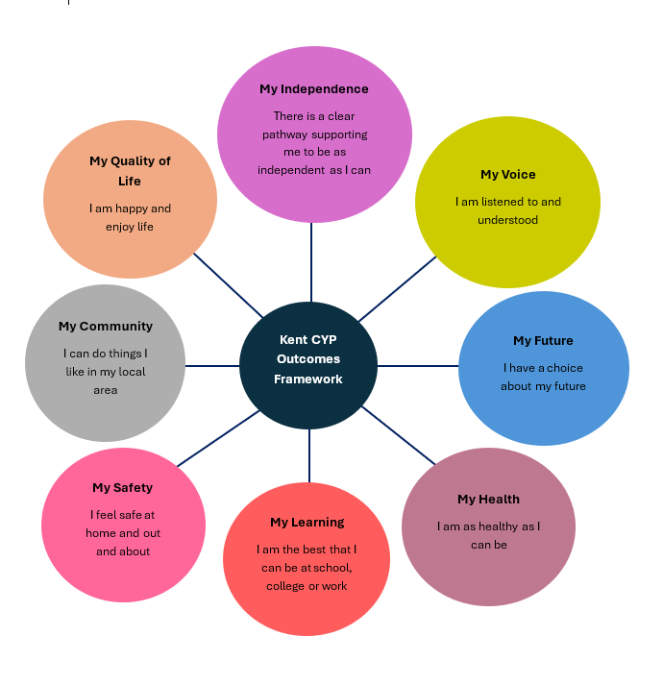

This is your chance to tell everyone supporting you what is going well, and what needs to change, in order to help you reach your full potential. The following questions will help us to understand more about you, and your views about your life.

This form can be printed off, to add your own ideas and thoughts in the blank grey boxes, if you would like. An adult can read for you, and /or write your answers for you, if you would like help; and you can break it down into smaller parts, if you don’t want to complete it all at once. Alternatively, this form can be completed electronically, using the text boxes to add typed comments and /or selecting thoughts and views using the tick boxes provided.

Please use the information gathered through Pupil Voice to inform the Annual Review Meeting in terms of Outcomes and Provision.

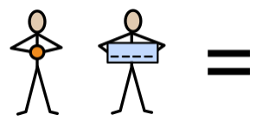
My name is:
Click or tap here to enter text.

Click or tap here to enter text.

My school/setting is called:
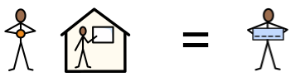

This information was provided by:
Please select the relevant statement below to represent how the child’s views were gathered to complete Appendix 1A:

Child/ Young Person’s views were captured by completion of this form and through observations and discussions with the child, their parent(s), carer(s) and relevant professionals. | ☐
The Child/Young Person’s was able to take part in developing their Education, Health and Care Plan (EHCP) by contributing their wishes and aspirations with their parents (s) and the professionals working with them. | ☐
Due to their severe and complex needs, the child/young person is unable to express their views directly. Therefore, their views have been provided by the child’s teacher and parent/carer. | ☐

Date of completed form:
Click or tap to enter a date.

Picture, drawing, or photo of me (optional):

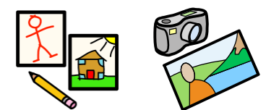

My aspirations (goals) for the future:
My Future

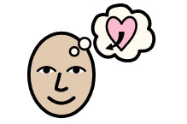

This year, I want to get better at: | 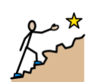 | Please use this box to draw / type / write any of your ideas:
When I grow up, I would like to be: | 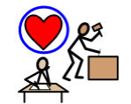 | Please use this box to draw / type / write any of your ideas:
My aspirations (goals) for the future:
My Future

What sort of work would you like to do?  (It is okay to say you are not sure.) |  | Please use this box to draw / type / write any of your ideas:
What skills or training would you need? | 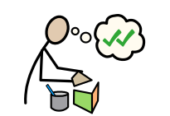 | Please use this box to draw / type / write any of your ideas:

I am working towards Independence, by:
My Independence

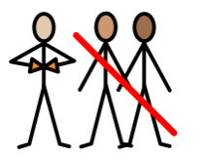

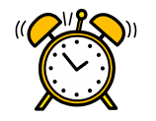 | 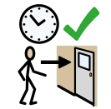 | 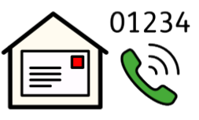 | 
Learning how to use / set an alarm clock  ☐ | Getting to my lessons on time, independently  ☐ | Knowing my telephone number and address  ☐ | Recognising when I need help, and being able to ask for it, appropriately  ☐
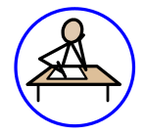 | 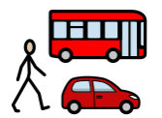 | 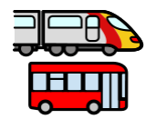 | 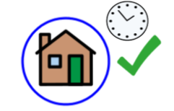
Completing homework tasks and handing them in on time, without reminders  ☐ | Travelling to and from school, independently  ☐ | Learning to use public transport, with support  ☐ | Returning home by an agreed set time  ☐

I am working towards Independence, by:
My Independence

Please use this box to draw / type / write any of your ideas:

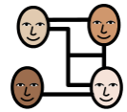 | 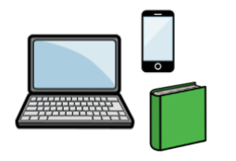 | 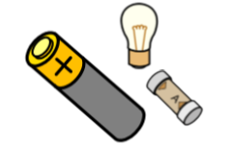 | 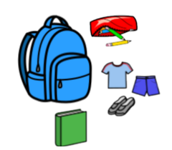
Making plans with friends, and carrying them out, independently  ☐ | Taking responsibility for my own equipment  (e.g., laptop, phone, school equipment, books, etc.)  ☐ | Taking responsibility for household jobs  (e.g., changing batteries or light bulbs, tidying my bedroom.)  ☐ | Having my equipment ready for school, without reminders  (e.g., PE kit, ingredients for cooking, etc.)  ☐
How I communicate best:
My Voice

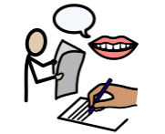

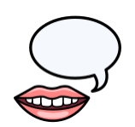 | 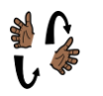 | 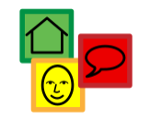 | 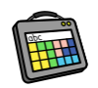
Talking  ☐ | Signing  ☐ | Using Symbols  ☐ | Augmentative Communication Aid  ☐
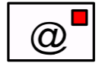 | 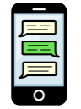 | 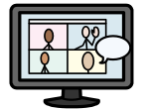 | 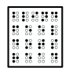
Email  ☐ | Texting  ☐ | Virtual Platform  ☐ | Reading Braille  ☐

Communication:
My Voice

Who listens to me, at home?  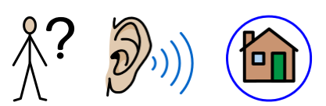 | Please use this box to draw / type / write any of your ideas:
Who listens to me, at my school, or in my setting?  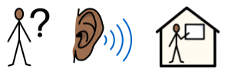 | Please use this box to draw / type / write any of your ideas:

To keep myself healthy, I:
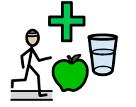

My Health

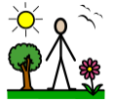 | 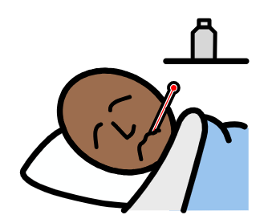 |  | 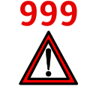 | 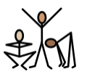
Spend time outside each day  ☐ | Tell someone when I feel unwell  ☐ | Keep my screen-time within healthy limits  ☐ | Know how to call 999/111 to look after myself, or someone else  ☐ | Stay physically active  ☐
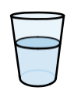 | 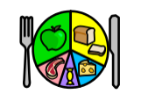 | 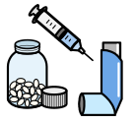 | 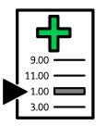 | 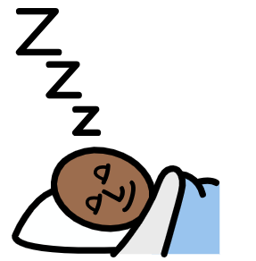
Stay hydrated  ☐ | Try to eat a variety of foods  ☐ | Take prescribed medication according to the prescription  ☐ | Attend health appointments, such as GP, dentist, and opticians  ☐ | Understand and ensure I have the amount of sleep I need  ☐
To keep myself healthy, I:
My Health

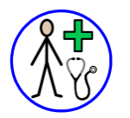 | 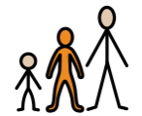 | 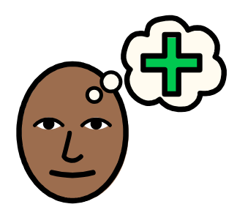 | 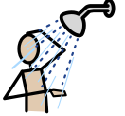
Know when I need to see a GP, and know what the GP can help me with  ☐ | Understand what puberty is, and the changes to male and female bodies  ☐ | Know how to access support for mental  health and wellbeing  ☐ | Manage my personal hygiene (wash daily, wear deodorant, brush teeth, etc.)  ☐
Please use this box to draw / type / write any of your ideas:

The best way for me to learn, is:
My
Learning

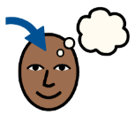

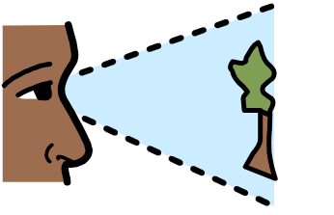 | 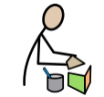 | 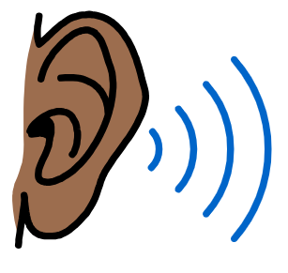 | 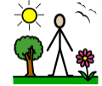 | 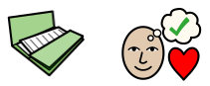
Visual  ☐ | Kinaesthetic (practical, hands-on, doing things)  ☐ | Auditory  ☐ | Out-door  ☐ | Project-based  ☐
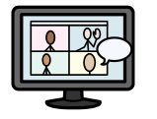 | 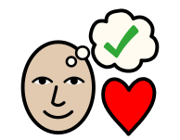 |  |  | 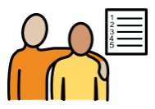
Via online learning platforms  ☐ | Special interest-based  ☐ | Watching Videos  ☐ | Life Skills-based  ☐ | Working towards and achieving my EHCP outcomes  ☐
Adults can help me, by:
My
Support

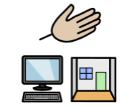

 |  | 
Reading my communication passport  ☐ | Providing me with preparation for change (e.g., a supply teacher or room change)  ☐ | Providing alternative methods  of recording  ☐
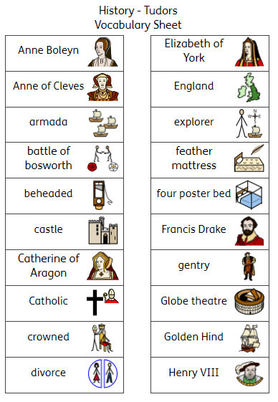 | 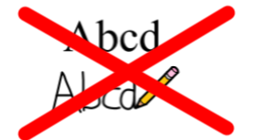 | 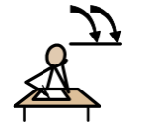
Providing me with subject-specific,  visual vocabulary banks  ☐ | Minimising tasks which require copying from the board; providing copies of PowerPoints or resources to highlight / annotate, where possible  ☐ | Teaching me active  strategies for revision  ☐

Adults can help me, by:
My
Support

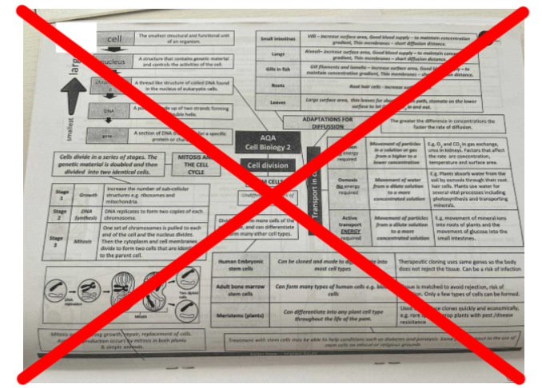 | 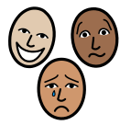 | 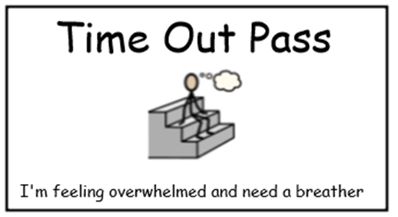 | 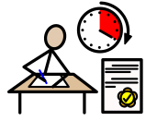
Ensuring worksheets use colour-coding and  are not too visually ‘busy’  ☐ | Providing regular emotional check-ins with a key adult, to resolve issues and monitor my wellbeing  ☐ | Providing me with an exit card and safe space to access, if I am feeling anxious or overwhelmed  ☐ | Providing me with exam access arrangements  ☐
Please use this box to draw / type / write any of your ideas:

I feel safe at school:
My
Safety

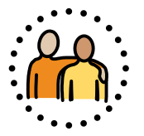
 |  | 
Yes  ☐ | No  ☐ | Unsure  ☐

Please use this box to draw / type / write any of your ideas:

Keeping myself safe:
My
Safety

Who can help me at home?   | Who can help me at school?  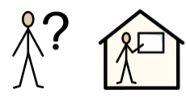
Please use this box to draw / type / write any of your ideas: | Please use this box to draw / type / write any of your ideas:
I would like adults to help teach me to keep safe, by:
My
Safety

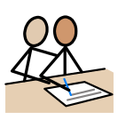 |  | 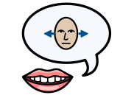 | 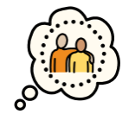
Supporting me to engage with services which support me (e.g., Therapies, Social Worker, etc)  ☐ | Teaching me the differences between healthy and unhealthy relationships  ☐ | Enabling me to understand my rights, and have confidence to say no to things I don’t feel comfortable with  ☐ | Ensuring that I have a trusted adult I can talk to about things which worry me  (parents, carers, setting staff)  ☐
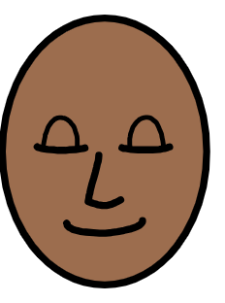 | 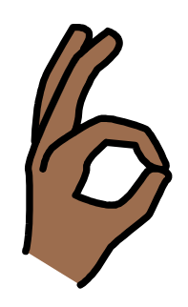 |  | 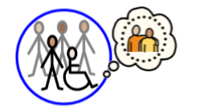
Teaching me strategies to cope with different emotions, other than using verbal or physical aggression  ☐ | Making sure I know which behaviours are appropriate, in my relationships  ☐ | Teaching me how to stay safe online  ☐ | Teaching me how to stay safe out in the community  ☐

I would like adults to help teach me to keep safe, by:
My
Safety

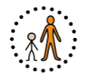 | 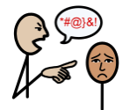 | 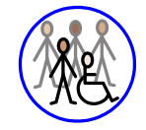
Ensuring that I have a trusted adult I can speak to, outside my home, if I have worries about relationships at home  ☐ | Teaching me what to do if I think I am being bullied  ☐ | Enabling me to have a social life I feel happy with, so I don’t feel isolated  ☐

Please use this box to draw / type / write any of your ideas:

Outside of my school or my setting, I enjoy:
My
Community

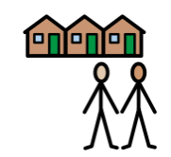

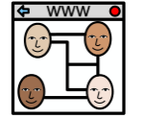 | 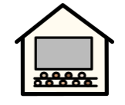 | 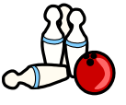
Social Media  ☐ | Cinema  ☐ | Bowling  ☐
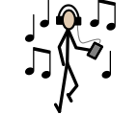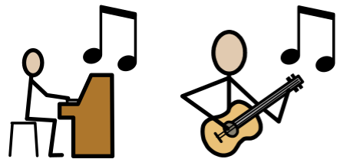 | 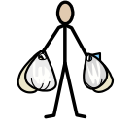 | 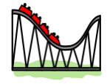
Listening to / Playing Music  ☐ | Shopping  ☐ | Theme Parks  ☐
Please use this box to draw / type / write any of your ideas:

Outside of my school or my setting, I enjoy:
My
Community

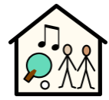 | 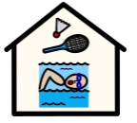 | 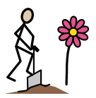 | 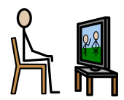
Youth Club  ☐ | Sports Club  ☐ | Community Projects  ☐ | Watching TV  ☐
 | 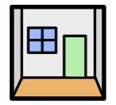 | 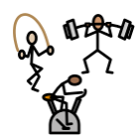 | 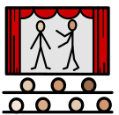
Playing video games  ☐ | Escape Rooms  ☐ | The gym  ☐ | Theatre  ☐

Do you know how to find out about things to do, within the community? | Would you like help to take part in activities, within the community?
Yes ☐ No ☐ | Yes ☐ No ☐
My quality of Life:
My Quality of Life



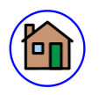 | 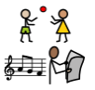 | 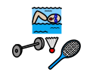 | 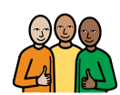 | 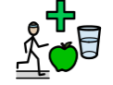 | 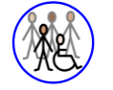
I have a comfortable and safe place to live  ☐ | I have daily activities which I enjoy  ☐ | I am involved in a community  ☐ | I have a trusted support network  ☐ | I have a healthy lifestyle  ☐ | I have a social life I feel happy with  ☐
At home, I am happy when I am with:
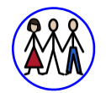 | 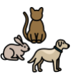 | 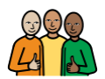
My family  ☐ | My pets  ☐ | My close friends  ☐

At my school or setting, overall:

My Setting: |   Yes  Yes |   No  No |   I don’t know
My Future – I have a choice about my future.  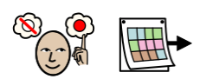 | ☐ | ☐ | ☐
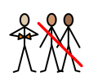  My Independence - I have the right support to enable me to be as independent as I can be. | ☐ | ☐ | ☐
My Voice - I feel listened to.  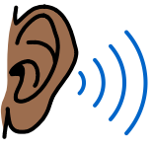 | ☐ | ☐ | ☐
My Health – I have the right health support to enable me to be as healthy as I can be.  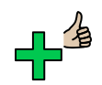 | ☐ | ☐ | ☐
My Learning/Support - I feel I have the right amount of support in my setting.  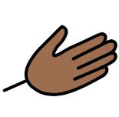 | ☐ | ☐ | ☐
My Safety - I feel safe.  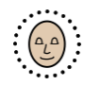 | ☐ | ☐ | ☐
My Quality of Life- I am happy and enjoy life. | ☐ | ☐ | ☐
My Community - I have a sense of belonging.  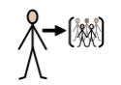 | ☐ | ☐ | ☐

Not Applicable  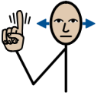 | Yes   | No   | Not Sure
☐ | ☐ | ☐ | ☐
I have been included in my Annual Review meeting:
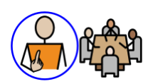

Please select Not Applicable if their annual review meeting has not been held yet meeting (the annual review meeting is held within a year after the EHCP of its first issue or from the date of the last review).
Anything else:
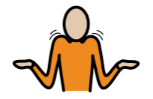

Comments:

