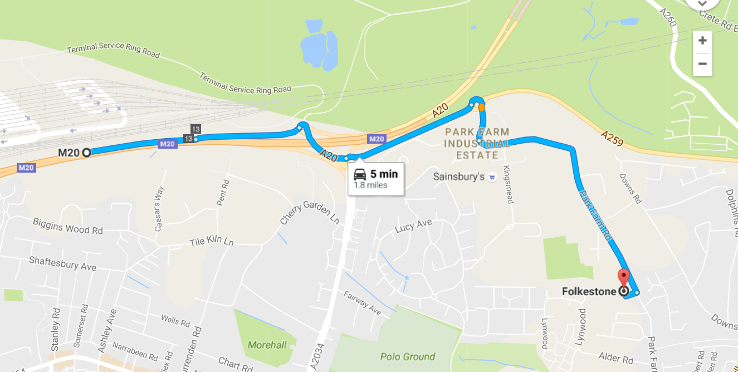
Directions to The Beacon, Folkestone via the M20
Exit at junction 13
Directions to The Beacon, Folkestone via the A20
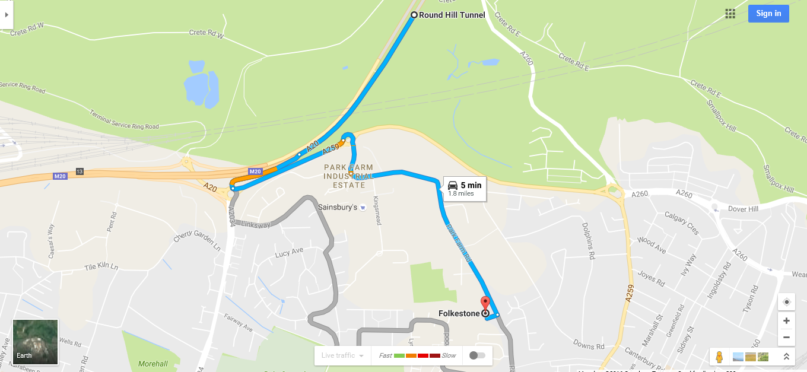
Exit towards the A259

